**SOFTWARE DESIGN DOCUMENT (SDD)**

**Smart Order and Inventory Management System (OMS)**

**1. DOCUMENT CONTROL**

| **Item** | **Details** |
| --- | --- |
| Project Name | Smart Order Management System |
| Version | 1.0 |
| Author | (Your Name) |
| Date | (Date) |
| Status | Final |

**2. PURPOSE OF THE DOCUMENT**

This document describes the **system architecture, design decisions, component structure, APIs, data models, and non-functional aspects** of the Smart Order Management System.

It is intended for:

* Developers
* Reviewers
* Interview discussions
* Maintenance & enhancement planning

**3. SYSTEM OVERVIEW**

**Business Objective**

Provide a scalable, secure, and maintainable system to:

* Manage users
* Manage products
* Place and track orders
* Support growth through microservices

**High-Level Features**

* User registration & login
* Product catalog management
* Order placement & tracking
* Role-based access (USER / ADMIN)

**4. ARCHITECTURE OVERVIEW (HLD)**

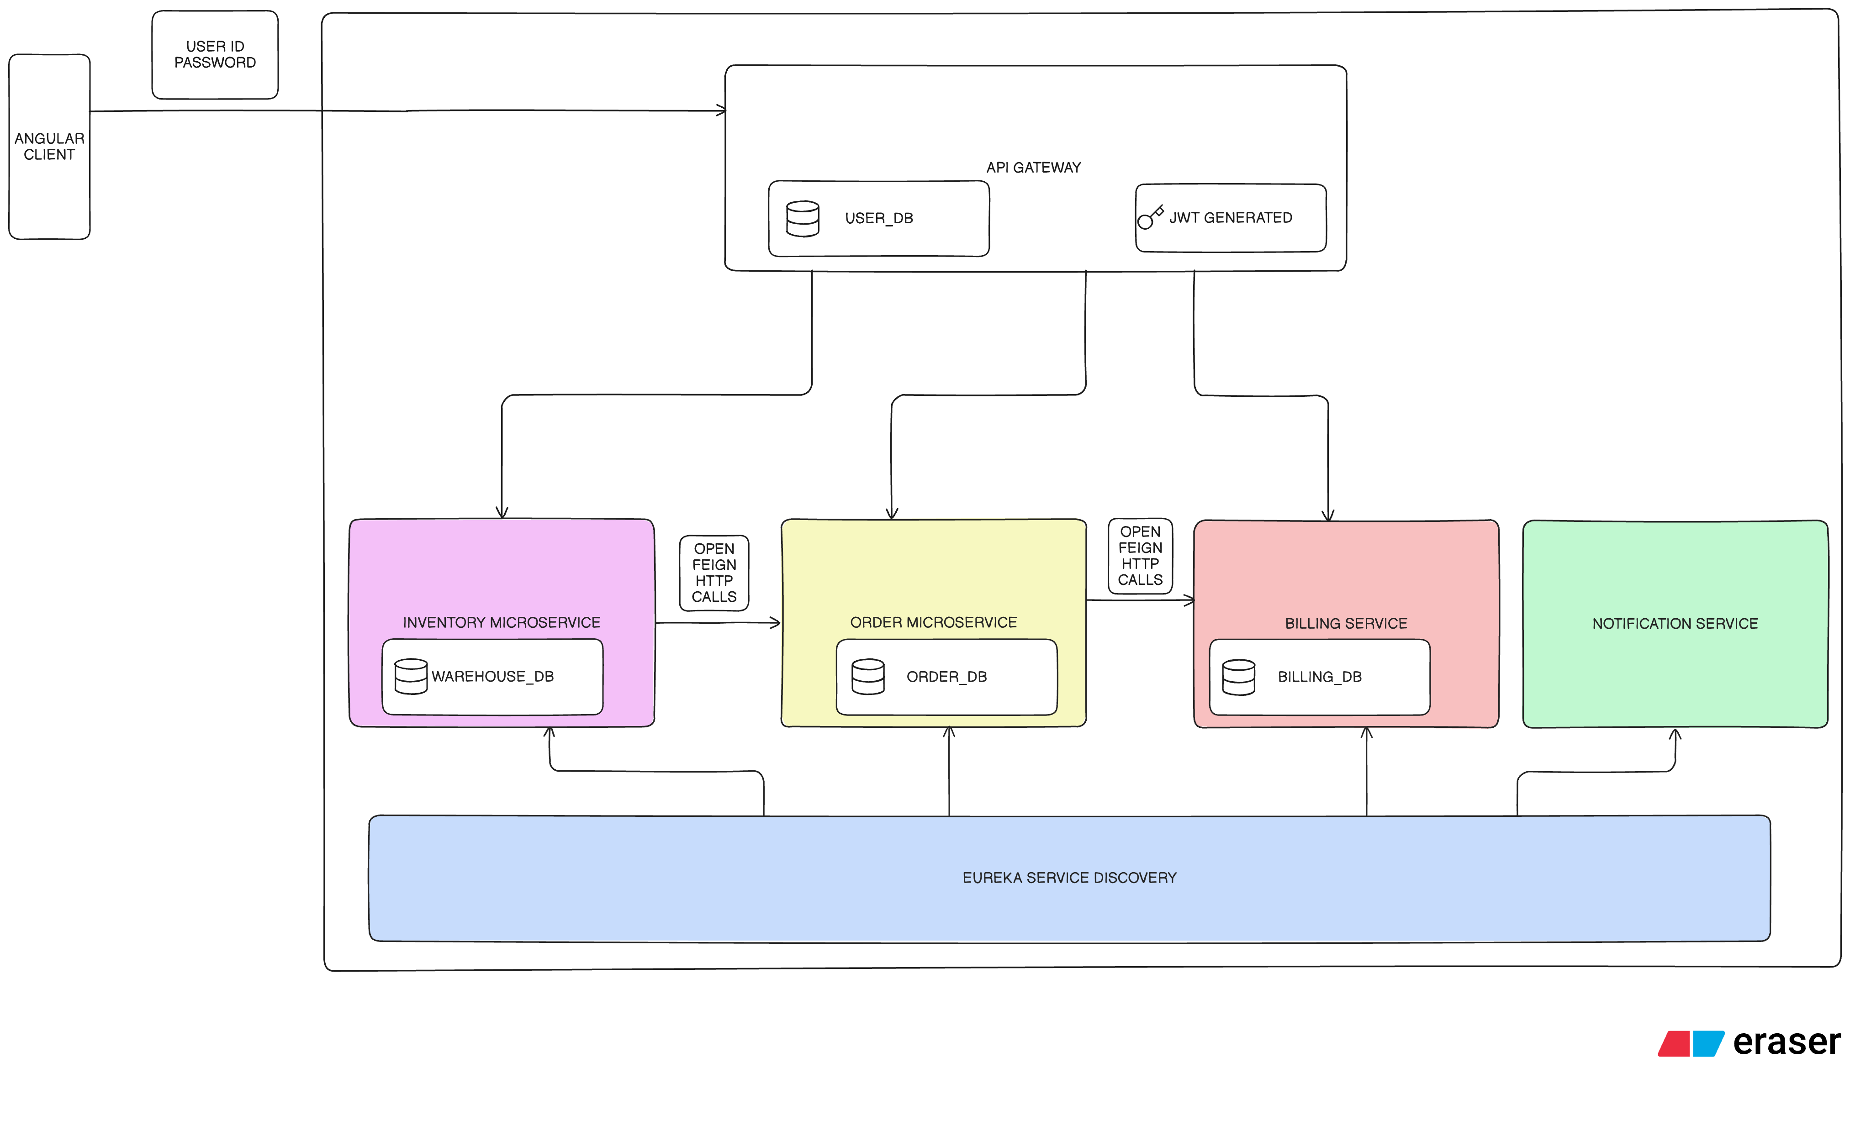

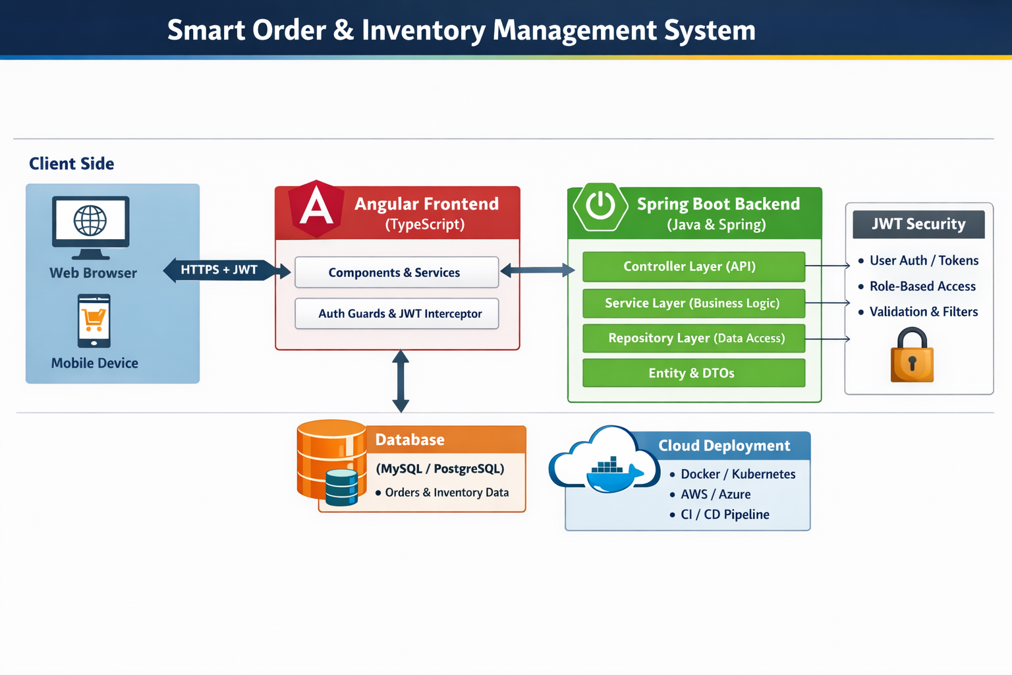

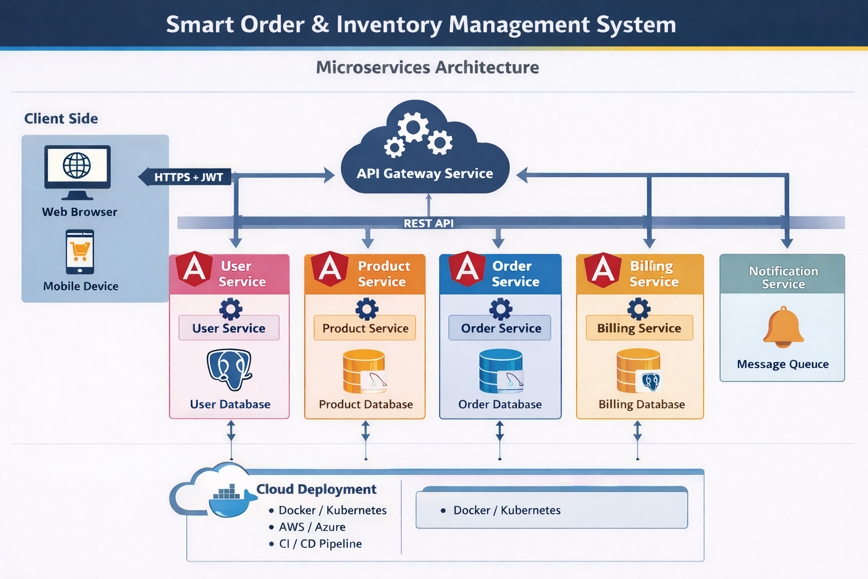

**SYSTEM DESIGN ARCHITECTURE**

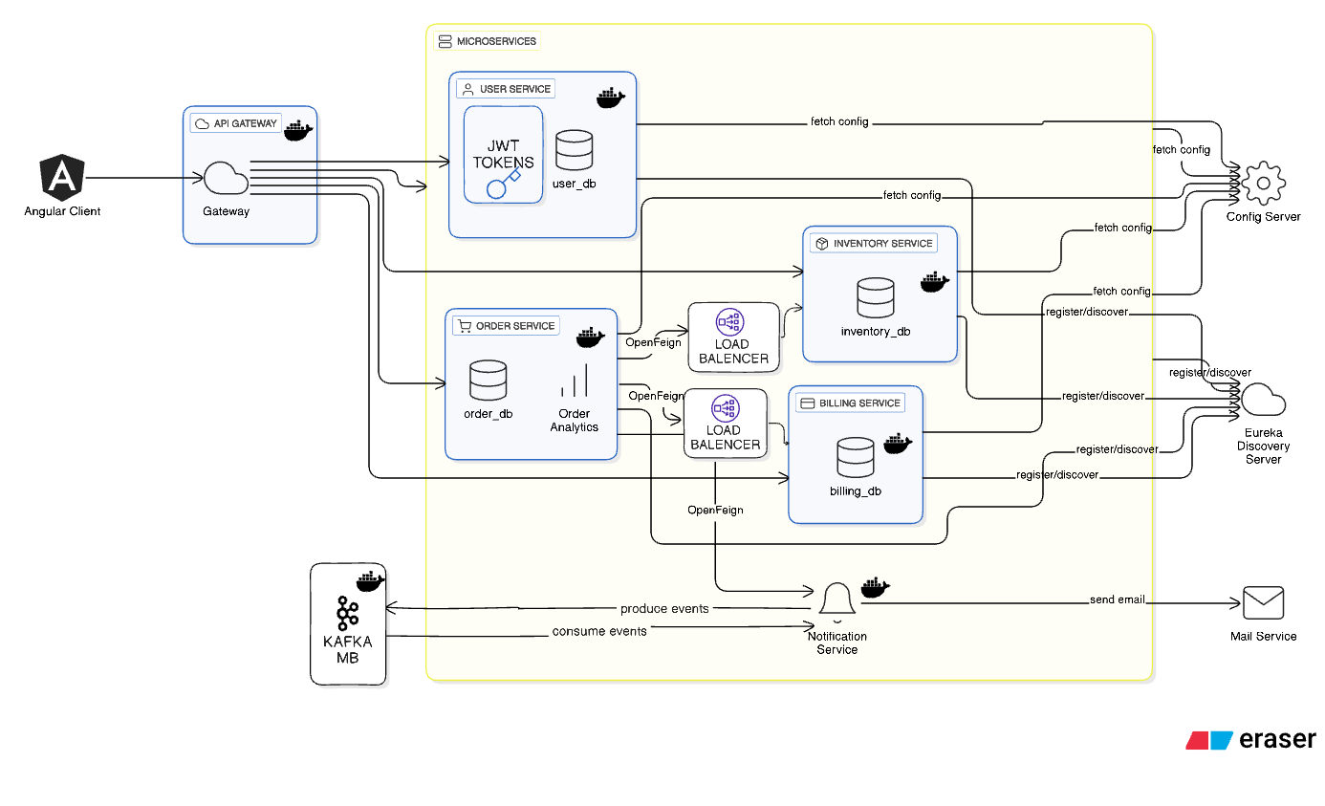

## Architecture Style

1. Microservices Architecture
2. REST-based communication
3. JWT-based security
4. Containerized deployment (Docker)
5. Scalable and loosely coupled design

## Core Components

1. Angular Frontend
2. API Gateway (for routing and security – optional)
3. User Service (Authentication & Authorization)
4. Product Service (Product catalog management)
5. Order Service (Order placement & tracking)
6. Billing Service (Invoice & payment handling)
7. Notification Service (Email / system notifications)
8. MongoDB (Dedicated database per microservice)
9. CI/CD Pipeline (Automated build, test, and deployment)

**5. TECHNOLOGY STACK**

**Backend**

* Java 17
* Spring Boot
* Spring Web
* Spring Data JPA
* Spring Validation

**Frontend**

* Angular
* Angular Material
* RxJS

**Database**

* MySQL(one DB per microservice)

**DevOps**

* Docker
* Docker Compose
* Jenkins
* SonarQube

**Testing**

* JUnit 5
* Mockito
* Spring Boot Test
* JMC
* JMeter

**6. MICROSERVICES DESIGN**

**6.1 User Service**

**Responsibilities**

* User registration
* Authentication
* Role management

**APIs**

|  |  |  |  |
| --- | --- | --- | --- |
| **METHOD** | **ENDPOINT** | **REQUEST PAYLOAD** | **RESPONSE PAYLOAD** |
| POST | /users/register | { name, email, password, role } | { userId} |
| POST | /users/login | { email, password } | { token, userId, role } |
| GET | /users/{id} | - | { userId, name, email, role } |
| GET | /users | - | [{ userId, name, email, role }] |
| PUT | /users/{id} | { name, email } | { userId, name, email, role } |
| DELETE | /users/{id} | - | { message } |
| PUT | /users/password/{id} | {currentPassword, newPassword} | - |

**Database**

* users database

**6.2 Product Service**

**Responsibilities**

* Product CRUD
* Inventory management

**APIs**

|  |  |  |  |
| --- | --- | --- | --- |
| **METHOD** | **ENDPOINT** | **REQUEST PAYLOAD** | **RESPONSE PAYLOAD** |
| POST | /product | {  "name": "Wireless Mouse",  "description": "Ergonomic wireless mouse",  "brand": "Logitech",  “specification”: {  "colors": ["Black", "White", "Blue"],  …  }  "price": 799.00,  "stock": 150  } | {  “id”:”P001”  } |
| GET | /products | — | [  {  "name": "Wireless Mouse",  "description": "Ergonomic wireless mouse",  "brand": "Logitech",  “specification”: {  "colors": ["Black", "White", "Blue"],  …  }  "price": 799.00,  "stock": 150  },  ….  ] |
| PUT | /products/{id} | {  "price": 899.00,  “specification”:{  "colors": ["Black", "Grey"],  }  } | 200 OK |
| DELETE | /products/{id} | — | 200 OK |
| GET | /products/{id} | - | {  "name": "Wireless Mouse",  "description": "Ergonomic wireless mouse",  "brand": "Logitech",  “specification”: {  "colors": ["Black", "White", "Blue"],  …  }  "price": 799.00,  "stock": 150  } |
| GET | /products/{name} | — | {  "name": "Wireless Mouse",  "description": "Ergonomic wireless mouse",  "brand": "Logitech",  “specification”: {  "colors": ["Black", "White", "Blue"],  …  }  "price": 799.00,  "stock": 150  } |
| PATCH | /products/{id}/stock | {  “quantity” : 30,  “operation” : “ADD”  } | 200 OK |
| GET | /products/{id}/stock | - | {  “id” : “P001”,  “stock” : 50  } |

**Database**

* products collection

**6.3 Order Service**

**Responsibilities**

* Order creation
* Order history
* Order status

**APIs**

|  |  |  |  |
| --- | --- | --- | --- |
| **METHOD** | **ENDPOINT** | **REQUEST PAYLOAD** | **RESPONSE PAYLOAD** |
| POST | /orders | {  "customerId": 12, "items": [ { "productId": 101, "quantity": 2 },  {"productId": 205, "quantity": 1 } ]  } | {  "orderId": 501,  "status": "CREATED", "totalAmount": 3499.00  } |
| GET | /orders/{orderId} | — | { "orderId": 501,  "status": "PACKED",  "items": [ { "productId": 101, "quantity": 2, "price": 999 },  { "productId": 205, "quantity": 1, "price": 1501 } ],  "totalAmount": 3499,  "warehouse": "BLR-WH-01"  } |
| GET | /orders/user/{userId}?page=0&size=10 | — | { "content": [ { "orderId": 501, "status": "DELIVERED", "totalAmount": 3499, "createdAt": "2025-12-27T10:45:12" }, { "orderId": 498, "status": "CANCELLED", "totalAmount": 1299, "createdAt": "2025-12-25T18:30:00" } ], "totalPages": 3, "totalElements": 21 } |
| GET | /orders/{id}/status | — | [ { "status": "CREATED", "changedAt": "2025-12-27T10:45:12", "changedBy": "customer" },  { "status": "APPROVED", "changedAt": "2025-12-27T11:10:00", "changedBy": "admin" },  { "status": "PACKED", "changedAt": "2025-12-27T12:40:00", "changedBy": "warehouse_manager" } ] |
| PUT | /orders/{id}/status | json { "status": "PACKED" } | { "orderId": 501, "oldStatus": "APPROVED", "newStatus": "PACKED", "updatedAt": "2025-12-27T12:40:00" } |
| PUT | /orders/cancel/{id} | — | { "orderId": 501, "status": "CANCELLED", "message": "Order cancelled successfully" } |

**Database**

* orders database

**6.4 Billing Service**

|  |  |  |  |
| --- | --- | --- | --- |
| METHOD | ENDPOINT | REQUEST PAYLOAD | RESPONSE PAYLOAD |
| POST | /billing/invoice | { orderId } | { invoiceId, orderId, amount, status, createdAt } |
| GET | /billing/invoice/{orderId} | — | { invoiceId, orderId, amount, tax, totalAmount, status } |
| PUT | /billing/payment/{invoiceId} | { paymentMode } | { invoiceId, paymentStatus, paidAt } |
| GET | /billing/status/{orderId} | — | { orderId, invoiceId, paymentStatus } |

**7. DATA DESIGN (LLD)**

**User Document**

{

"id": "u101",

"email": "user@test.com",

"password": "encrypted",

"role": "USER",

"active": true

}

**Product Document**

warehouse (

id BIGINT PK,

name VARCHAR(100),

location VARCHAR(150),

is_active BOOLEAN,

created_at TIMESTAMP

)

inventory (

id BIGINT PK,

product_id BIGINT,

warehouse_id BIGINT,

total_quantity INT,

available_quantity INT,

reserved_quantity INT,

low_stock_threshold INT,

UNIQUE (product_id, warehouse_id)

)

stock_reservation (

id BIGINT PK,

order_id BIGINT,

product_id BIGINT,

warehouse_id BIGINT,

quantity INT,

status VARCHAR(20), -- RESERVED, RELEASED, COMMITTED

reserved_at TIMESTAMP

)

fulfillment (

id BIGINT PK,

order_id BIGINT,

warehouse_id BIGINT,

status VARCHAR(20),

packed_at TIMESTAMP,

dispatched_at TIMESTAMP,

delivered_at TIMESTAMP

)

**Order Document**

{

"orderId": "o501",

"userId": "u101",

"items": [

{ "productId": "p201", "qty": 1 }

],

"totalAmount": 30000,

"status": "PLACED"

}

**8. API DESIGN & VALIDATION**

* RESTful principles
* JSON request/response
* Bean Validation at DTO layer
* Service-level business rule enforcement
* Standard HTTP status codes

**9. ERROR HANDLING STRATEGY**

**Global Exception Handling**

* Centralized using @ControllerAdvice
* Standard error response format

{

"timestamp": "2025-01-01T10:00:00",

"status": 400,

"error": "Validation Error",

"message": "Price must be greater than zero"

}

**10. SECURITY DESIGN**

* Password encryption (BCrypt)
* Role-based access control
* JWT authentication (optional enhancement)
* Secure API access

**11. NON-FUNCTIONAL REQUIREMENTS**

| **Area** | **Design Decision** |
| --- | --- |
| Scalability | Stateless services, Docker |
| Performance | Caching, async calls |
| Availability | Independent services |
| Maintainability | POM-like layered backend |
| Security | Validation, encryption |
| Observability | Logging & monitoring |

**12. TESTING STRATEGY**

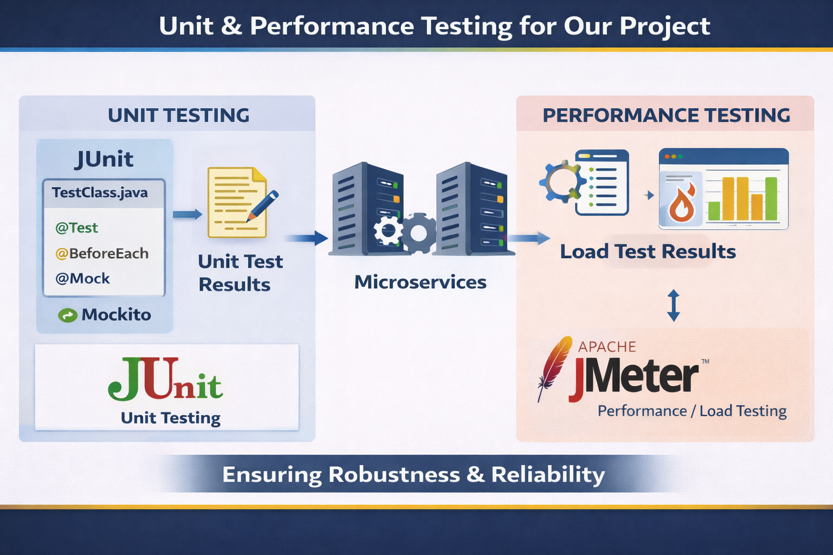

**Backend**

* Unit tests (Service layer)
* Controller tests (MockMvc)
* Minimum 80% COVERAGE

**Frontend**

* Component tests
* Service tests

**Quality Gates**

* SonarQube enforced
* Build fails on violations

**13. CI/CD DESIGN**

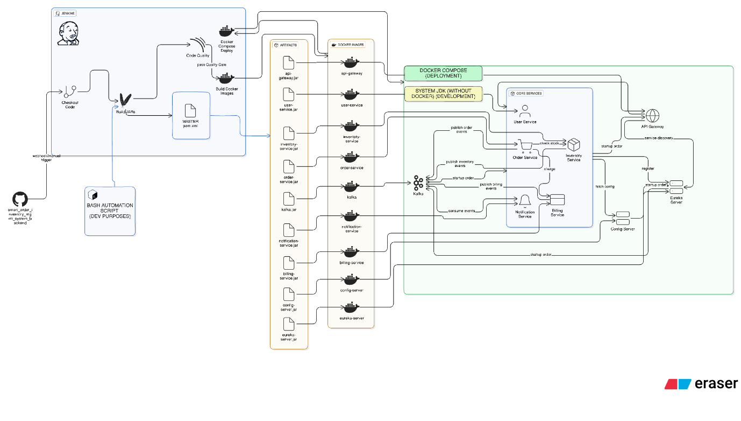

**Pipeline Flow**

1. Git Commit
2. Jenkins Build
3. Unit Tests
4. SonarQube Scan
5. Quality Gate Check
6. Docker Build
7. Docker Compose Deploy

**14. DEPLOYMENT DESIGN**

* Docker image per microservice
* docker-compose for orchestration
* Environment-specific configs

**15. ASSUMPTIONS & CONSTRAINTS**

**Assumptions**

* Services communicate over REST
* MongoDB available
* Docker environment present

**Constraints**

* No distributed transactions
* Event-driven architecture out of scope

**16. FUTURE ENHANCEMENTS**

* Spring Cloud Gateway
* Kafka-based async communication
* Kubernetes deployment
* Centralized logging (ELK)

**17. CONCLUSION**

This design ensures:  
✔ Clean separation of concerns  
✔ Scalability & maintainability  
✔ Testability & CI/CD readiness  
✔ Interview-ready explanation

**SEQUENCE DIAGRAMS — SMART ORDER MANAGEMENT SYSTEM**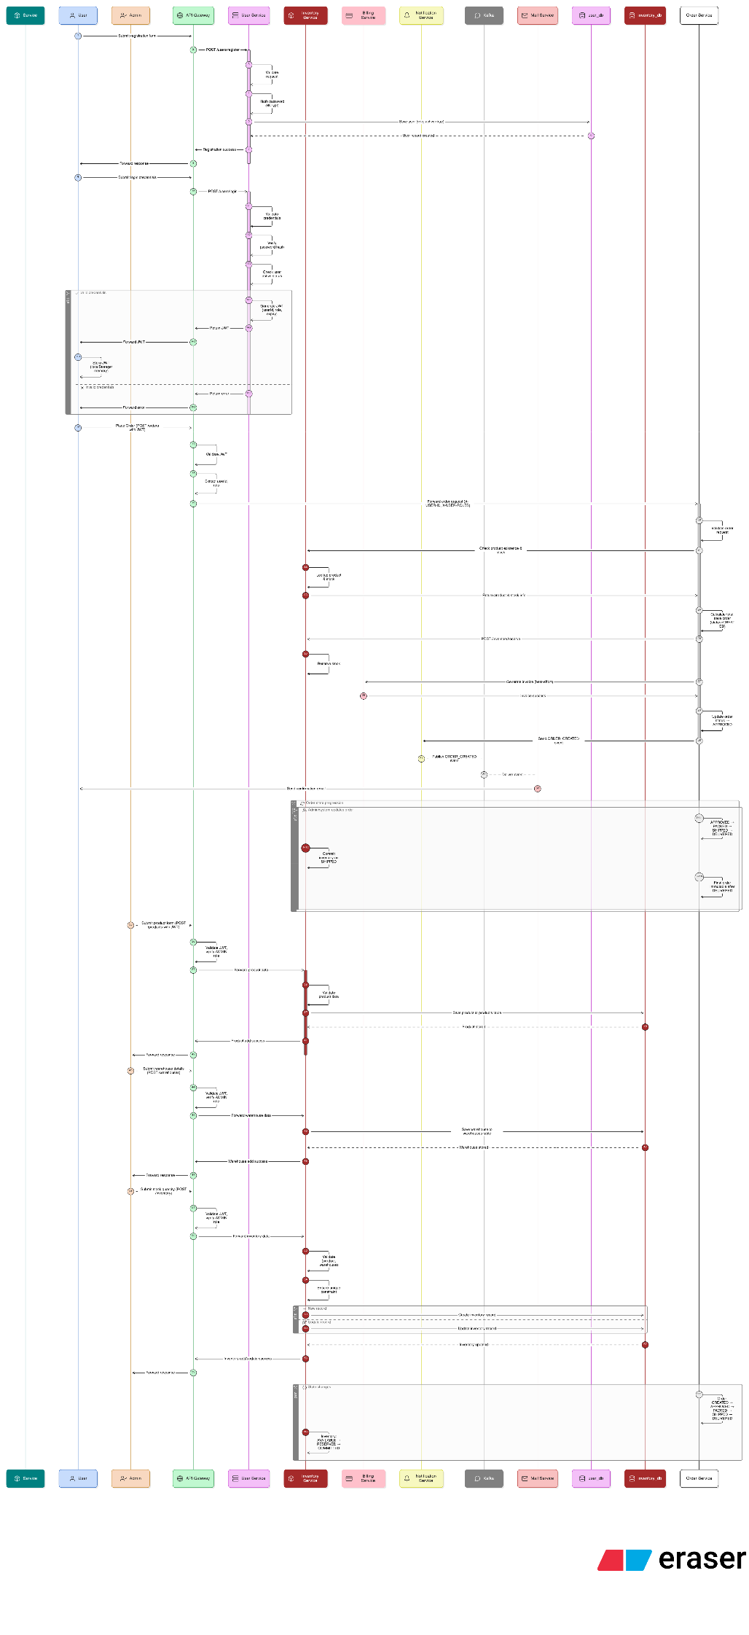

**1. User Registration — Sequence Diagram**

**Scenario**

A new user registers using the Angular UI.

**Flow**

1. User enters details in Angular UI
2. Angular sends POST /users/register to User Service
3. User Service validates request (email, password)
4. User Service checks email uniqueness in MongoDB
5. Password is encrypted
6. User is saved in MongoDB
7. Success response sent back to UI

**Participants**

* User
* Angular UI
* User Service
* MongoDB

**Key Design Points**

* Validation at API boundary
* Encryption at service layer
* No direct DB access from UI

**2. User Login — Sequence Diagram**

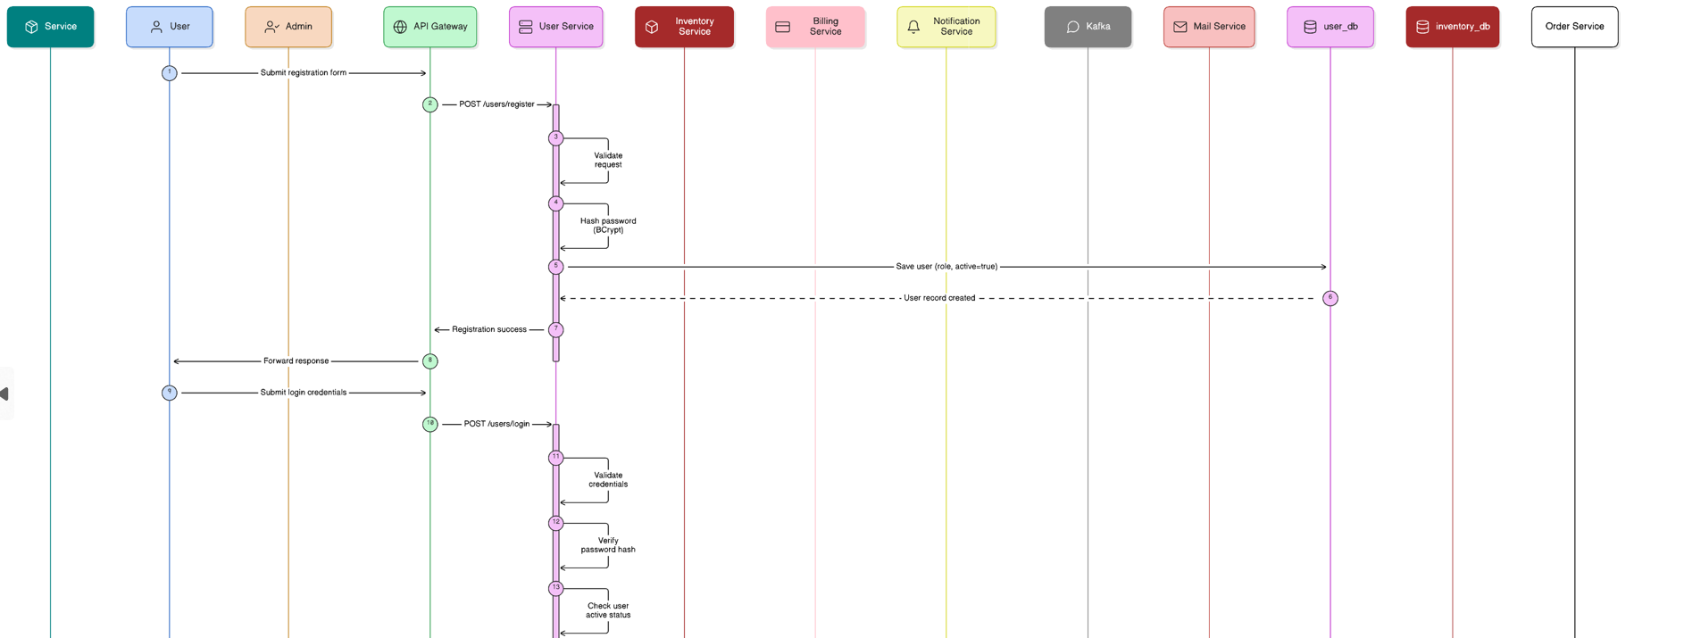

**JENKINS PIPELINE**

pipeline {

agent any

tools {

maven 'maven-3' // Make sure this Maven installation exists in Jenkins

}

stages {

stage('Checkout Code') {

steps {

git branch: 'main',

url: 'https://github.com/QuantumSoham/smart_order_inventory_mgmt_system_backend.git'

}

}

stage('Build Backend Jars') {

steps {

echo "Building all microservices jars (skipping tests)..."

bat 'mvn clean package -DskipTests=true'

}

}

stage('Build Docker Images') {

steps {

echo "Building Docker images for all microservices..."

bat 'docker build -t api-gateway ./api-gateway'

bat 'docker build -t billing-service ./billing-service'

bat 'docker build -t eureka-server ./eureka-server'

bat 'docker build -t inventory-service ./inventory-service'

bat 'docker build -t order-service ./order-service'

bat 'docker build -t user-service ./user-service'

}

}

stage('Run Docker Compose') {

steps {

dir('backend') {

echo "Starting all containers with Docker Compose..."

bat 'docker compose up -d --build'

}

}

}

}

post {

success {

echo "Pipeline completed successfully!"

}

failure {

echo "Pipeline failed. Check the logs for errors."

}

}

}